**CPEG 585 – Assignment #3**

1. Implement the Laplacian of Gaussian (LoG) using a two-step approach i.e., apply the Gaussian kernel and then compute the Laplacian of the image.

Image 1:

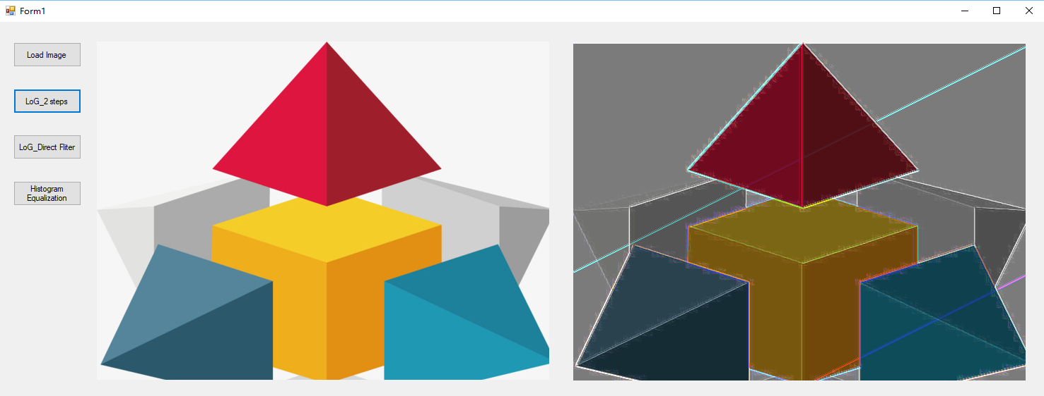

Image 2:

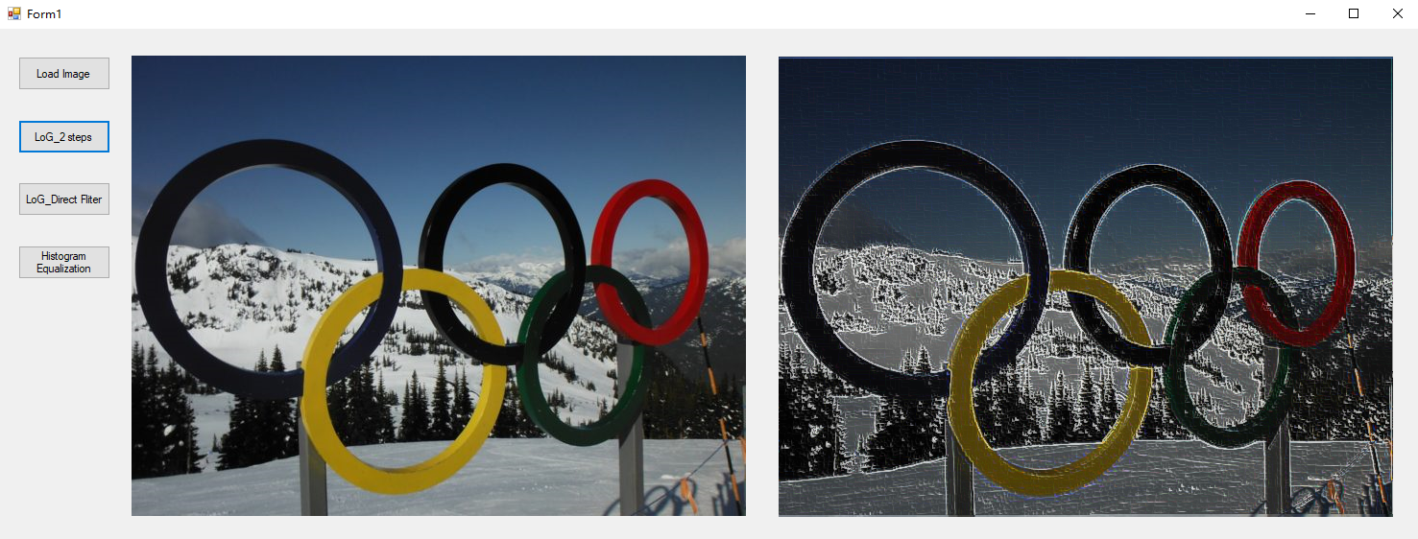

Image 3:



As a result, the edges have been enhanced for edge detection.

2. Implement the LoG using the combined kernel approach where the kernel is given by: 

Image 1:

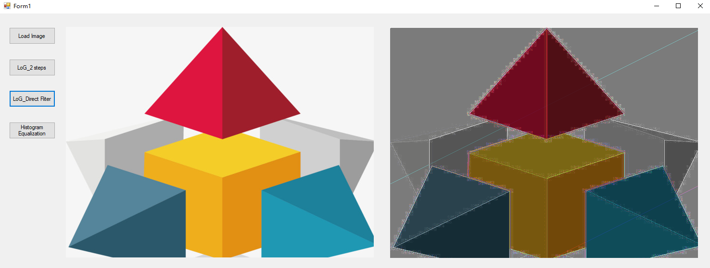

Image 2:

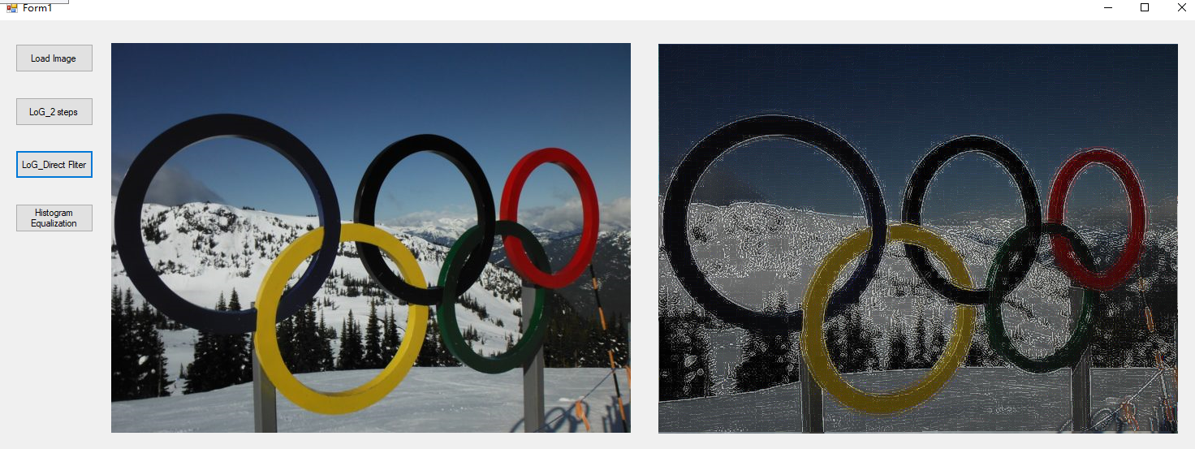

Image 3:

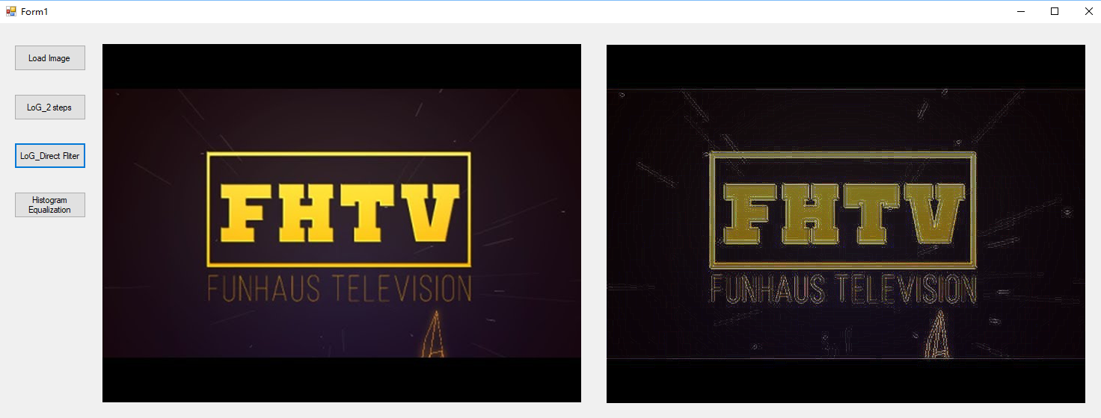

As a result, the edges have been enhanced for edge detection.

3. Implement the Histogram Equalization Algorithm and test on a few different images.

Image 1:

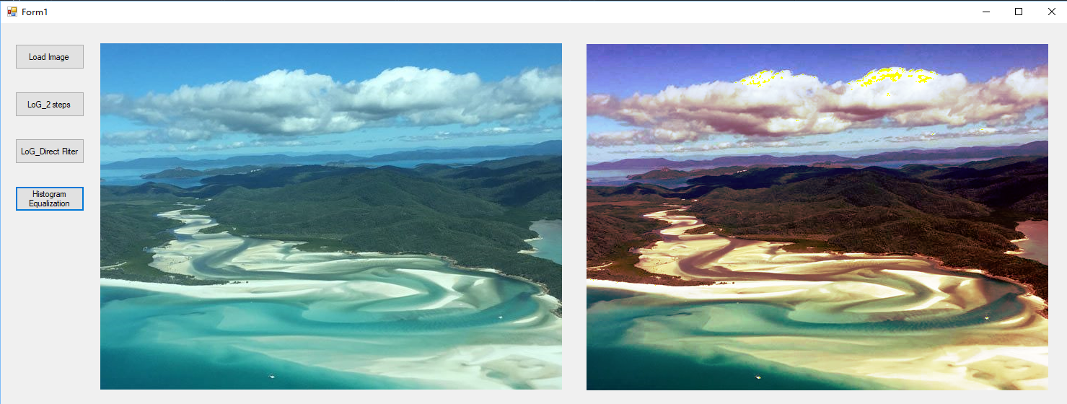

Image 2:

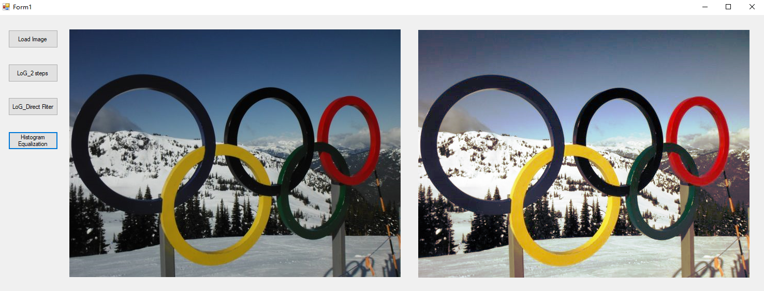

Image 3:

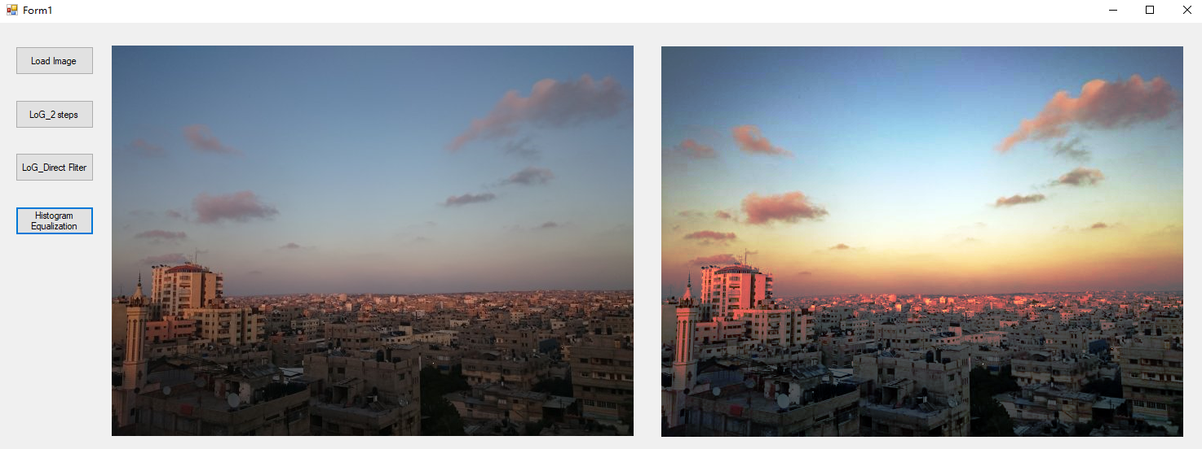

Histogram Equalization used color images by operating the Red, Green and Blue components of the image separately. It results in whiten images.

4. Use OpenCV to test Canny Edge Detection in Python.

Image 1:

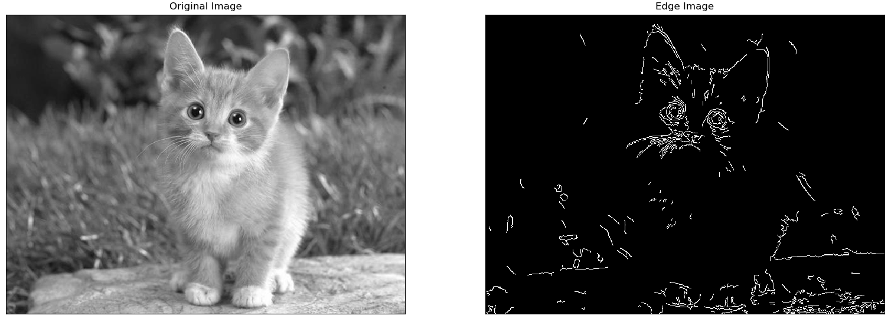

Image 2:

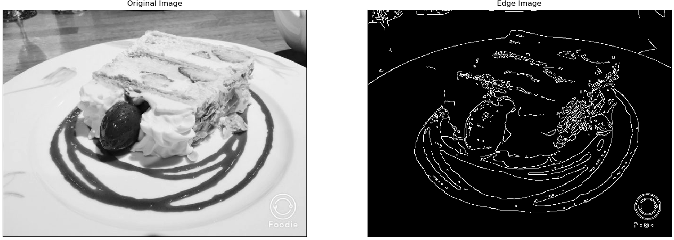

Image 3:

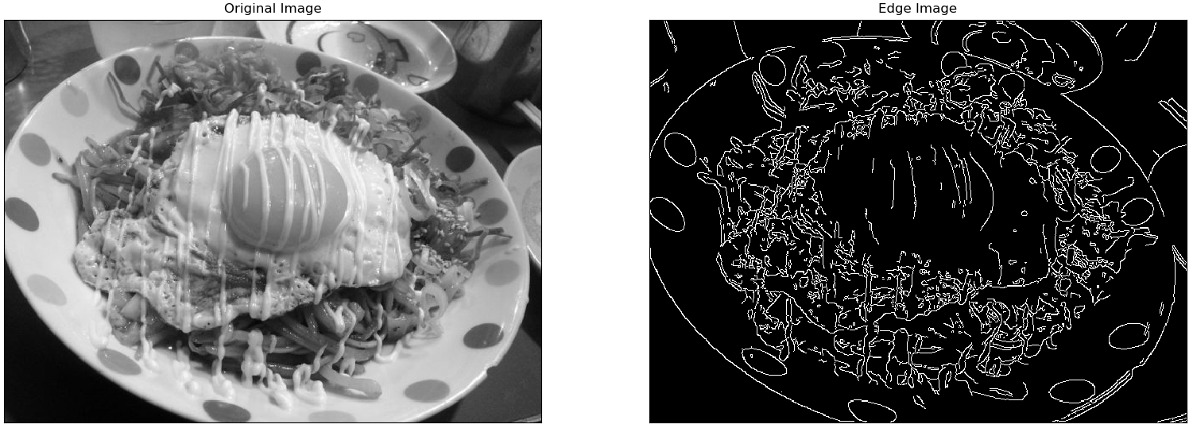

As a result, the edges of images have been extracted for edges detection (got a binary image with “thin edges”.).

5. Use OpenCV to test Harris Corner Detection in Python.

Image 1:

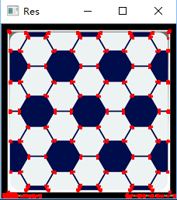

Image 2:

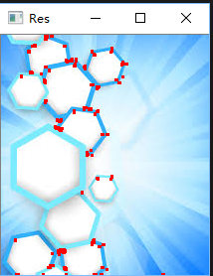

Image 3:

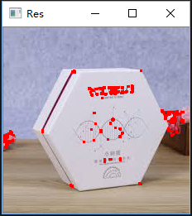

As a result, the corners of images have been extracted for corners detection (marked in red pixels).